Join us for the 18th Annual
Fall Harvest Gathering for
Women in Sustainable Agriculture
November 10-12, 2017
Whalan, Minnesota
$135 includes lodging/$120 early-bird registration
(This is a bring your own food and beverages setting-details below)

Farm Legacies for Our Communities
Presented by Teresa Opheim
Come explore your agricultural and environmental legacy and your hopes for the future of our rural landscape. The Women’s Fall Gathering will include opportunities to reflect on your own about your agriculture and/or environmental legacy, write or be interviewed by others, and participate in group conversations. We hope you leave the Gathering with a legacy letter you can share with others (if you wish). Don’t worry if you find it hard to write—we will help you!

Teresa Opheim is the editor of The Future of Family Farms: Practical Farmers’ Legacy Letter Project, the former Executive Director of Practical Farmers of Iowa and now a Senior Fellow at Practical Farmers and at Renewing the Countryside.
.
Virtual Farm Tours presented by Tika Bhandari and Andrea Vaage from Global Greens, Hannah Breckbill and Dayna Burtness (see page 3 for bios)

Fall Gathering Schedule at Cedar Valley Resort
Friday, November 10th
5 to 7:30 pm | Fall Gathering registration and supper
7:30 | Welcome, opening circle and introductions
Saturday, November 11th
8:30 am | Welcome, announcements, new introductions
9-9:45 am | Virtual tour
9:45-10:30 am | Virtual tour
10:30- 12:00 | Presentation by Teresa
12:00- 2 pm | Lunch, conversation, recreation
2-2:45 pm | Virtual tour
3 - 5 pm | Presentation by Teresa
5 pm | Break and meal prep
6 pm | Supper
7:30 pm | Reflections on Teresa’s presentation and last year’s World View Skills
8 pm | Bonfire and music
Sunday, November 12th
8:30 to 9:30 | Wrap up, closing, silent auction
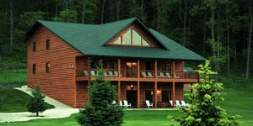
All women are welcome!
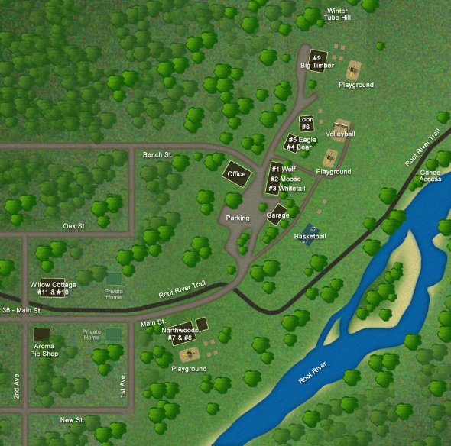
Some of us farm and some of us are sustainable agriculture advocates and friends, but we all enjoy sharing and learning from each other at the annual Fall Harvest Gathering for Women in Sustainable Agriculture.
November 10-11-12, 2017
Cedar Valley Resort in Whalan, MN.

Registration: $120 in advance, $135 after November 3. Includes lodging and some meals (see ‘Food’ below).
Scholarships to cover registration are available on a limited basis. Financial need and first time attendees are given priory, all are encouraged to apply. Please write a short email explaining why you want a scholarship, also include full contact information. Send to: Bonnie, find contact info below
Lodging: We will be sharing several large, modern cabins with multiple bedrooms at Cedar Valley Resort (http://cedarvalleyresort.com/). To keep costs low, we ask that you share rooms. Please let us know on the registration form if you know who you’d like to share a room with.
Food: Conference organizers and participants bring in all food and beverages for the weekend. Cabins have kitchen facilities. Feel free to bring your own favorite foods and beverages for breakfasts and Saturday lunch. Saturday dinner is a potluck. Please bring soups and stews, breads, cheese, desserts, drinks and other foods to pass. Light snacks, breakfast offerings, and Friday chili dinner are provided.
Activities: Cedar Valley is on the Root River and provides access to trails and boat landings for hiking, canoeing, or fishing.
Silent Auction: Please bring a donation for the silent auction. The proceeds are used to help offset speaker costs, for scholarships to the gathering, and to help pay the deposit for next year’s gathering.
Music: We will have music Saturday evening, as well as other times, and encourage you to bring your instrument, singing voice and favorite songs!
Make checks payable to ‘Melissa Driscoll’ and fill out form below. Mail check and registration form to Bonnie Haugen, 12620 Deer Road, Canton, MN 55922. We are unable to take credit card payments—sorry! For more info, contact Bonnie at bonnie.haugen@gmail.com or 507-421-7170

Name: ____________________________________________________________________
Organization or Farm Name: _____________________________________________________________
Address: _____________________________________________________________________________
Telephone: ____________________________ Email: ________________________________________
Amount enclosed: Early registration ($120) ______ Late/walk-in- after Nov. 6 ($135) __________
Saturday only ($80) ______ Donation to program/scholarships _______
I want to share a room with (if known): ___________________________________________________
We will be sending out a confirmation letter to registrants a few days before the gathering.
Virtual Tour Presenters
*LSI’s Global Greens agricultural programs coordinate land access, production, education and business development training for refugees in the Des Moines metro who want to reconnect with the land. Global Greens manages community gardens, a training farm, farmers’ market and CSA.
Tika Bhandari is a former refugee from Bhutan. She spent 16 years in a refugee camp in Nepal before moving to Des Moines, Iowa in 2008. Tika obtained a Master in Sociology in her home country, but had to start over when she came to the United States. She has been a farmer with Global Greens since 2013 and is a Bilingual Community Associate with LSI. Tika sells her produce at the Global Greens Farmers’ Market and CSA, Downtown Des Moines Farmers’ Market, Iowa Food Coop and elsewhere.
Andrea Vaage is an AmeriCorps VISTA for Global Greens. She works in program marketing and expanding vendor opportunities at the Global Greens Farmers’ Market. She is an author of Iowa State Extension publication, Municipal Zoning for Local Foods in Iowa, and has worked on several CSAs throughout the Midwest. Andrea holds a Master’s Degree in Sustainable Agriculture and Community and Regional Planning from Iowa State University.
*Hannah Breckbill owns and co-operates Humble Hands Harvest, a mostly-vegetable farm in Decorah, Iowa. This is the fifth year of Humble Hands Harvest, but the first year on permanent land. Hannah will talk about her farm operation, her farm dreams, both personally and for the world, and the incredible gathering of community that it took to get her farm up and running.
*Dayna Burtness runs Nettle Valley Farm, a small farmstead near the pretty little town of Spring Grove in southeast MN. She and her husband Nick raise beyond organic pastured pigs for families and chefs on about 70 acres of woods and pasture. Dayna has been working on all things food and farming since 2005 as a student farmer, a farmers market assistant manager, a local foods policy wonk, failed rooftop farm entrepreneur, wholesale vegetable farmer, restoration agriculture earthworks assistant, and now livestock farmer. (She's 99% sure this last one will stick!)
How to get there
Directions to Cedar Valley Resort (near Lanesboro, MN):
Go to http://www.cedarvalleyresort.com/map.htm for a map.

From Lanesboro:
4 miles down Highway 16 East from Lanesboro. Turn left off Highway 16, cross the bridge into Whalan. Go straight ahead 5 blocks (no turns) the road dead ends at the resort
From the Twin Cities:
1. Follow Hwy 52 all the way to Fountain
2. At Fountain take a left on County Rd #8 east to Lanesboro
3. At Parkway (Stop sign) take a right for approx. 5 blocks to stop sign.
4. Take a left on Hwy #16 East 4 miles to Whalan.
5. Turn left off Highway 16, cross bridge into Whalan and go straight ahead 5 blocks, the road dead ends at our resort. (On Main Street)
From Iowa:
1. Take I -35 to Albert Lea
2. Take I-90 East at Albert Lea past Austin to Dexter and Hwy 16 exit.
3. Just before Preston you'll come to a stop sign ( intersection of Hwy 16 & 52)
4. Take a right at stop sign and continue east on Hwys 16 & 52 through Preston
5. About 2 miles out of Preston Hwy 16 & 52 split at John Deere Implement.
6. Stay on Hwy 16 east (angles to left before John Deere) toward Lanesboro.
7. Stay on Hwy 16 east through Lanesboro. Whalan will be 4 miles past Lanesboro.
8. Turn left off Hwy 16, cross bridge into Whalan and go straight ahead 5 blocks, the road dead ends at our resort.(On Main Street)

