The Local Food Connection: Creating Connection that Builds Business
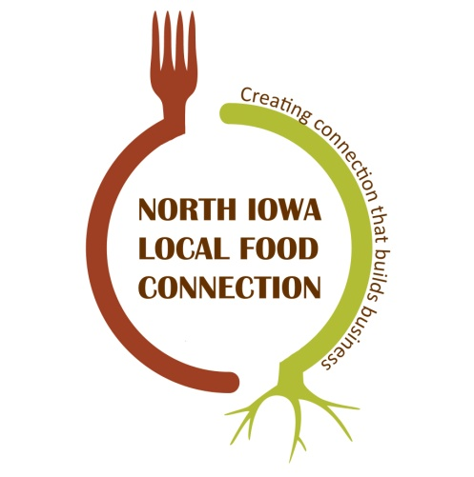
Healthy Harvest of North Iowa is excited to launch a new program of producer support. that will integrate both social networking - getting to know and find business connections with other local food producers and businesses - and specific business development workshops. There will be a lot of learning together and participants will have opportunity for input on lots of details about this program. NE Iowa operated a similar program last year and it has been very engaging and successful. We hope N. Iowa will experience the same.
The Local Food Connection will convene regular meetings of local food farmers allowing participants to identify and prioritize topics for business management focused seminars, workshops, field days, and consulting opportunities. This is open to producers of a wide range of products from fruit and vegetable to meat to wineries and breweries to producers who may not even be producing for the local market yet.
This is not just a sit down and listen workshop; interactive activities will be used throughout to help strengthen connections between participants and connections that build business. There will also be opportunity for one on one business coaching.
Our goal is that The Local Food Connection will build a vibrant learning community
We will discuss an online communication system to facilitate ease of ongoing learning and information sharing among network participants. We will develop a series of business resources out of this project; those will be housed on the Healthy Harvest website
First meeting is scheduled for Sun., Nov. 19, 3 - 5 pm to be held at the Forum Room of One Vision (1200 N. 9th St W.., Clear Lake 50428). Use the front (east most) parking lot, enter through the east doors. The Forum room will be the first room on the right.
Please bring a snack to share and your own beverage (no alcohol).

This is funded, in part, with support from a USDA Rural Business Development Grant.

Healthy Harvest of North Iowa mission is to lead and strengthen diverse partnerships to build a sustainable regional and local food system that brings health and vitality to our communities.
Our focus is on technical support to producers, communities, and working with our regional partners.
Contact: libbey.jan@gmail.com or 515/851-1690

